Credit Card Fraud Detection Using Hidden Markov Model

Abstract:

Now a day the usage of credit cards has dramatically increased. As credit card becomes the most popular mode of payment for both online as well as regular purchase, cases of fraud associated with it are also rising. In this paper, we model the sequence of operations in credit card transaction processing using a Hidden Markov Model (HMM) and show how it can be used for the detection of frauds. An HMM is initially trained with the normal behavior of a cardholder. If an incoming credit card transaction is not accepted by the trained HMM with sufficiently high probability, it is considered to be fraudulent. At the same time, we try to ensure that genuine transactions are not rejected. We present detailed experimental results to show the effectiveness of our approach and compare it with other techniques available in the literature.

Existing System:

In case of the existing system the fraud is detected after the fraud is done that is, the fraud is detected after the complaint of the card holder. And so the card holder faced a lot of trouble before the investigation finish. And also as all the transaction is maintained in a log, we need to maintain a huge data. And also now a days lot of online purchase are made so we don’t know the person how is using the card online, we just capture the IP address for verification purpose. So there need a help from the cyber crime to investigate the fraud. To avoid the entire above disadvantage we propose the system to detect the fraud in a best and easy way.
Proposed System:

In proposed system, we present a Hidden Markov Model (HMM).Which does not require fraud signatures and yet is able to detect frauds by considering a cardholder’s spending habit. Card transaction processing sequence by the stochastic process of an HMM. The details of items purchased in Individual transactions are usually not known to any Fraud Detection System(FDS) running at the bank that issues credit cards to the cardholders. Hence, we feel that HMM is an ideal choice for addressing this problem. Another important advantage of the HMM-based approach is a drastic reduction in the number of False Positives transactions identified as malicious by an FDS although they are actually genuine. An FDS runs at a credit card issuing bank. Each incoming transaction is submitted to the FDS for verification. FDS receives the card details and the value of purchase to verify, whether the transaction is genuine or not. The types of goods that are bought in that transaction are not known to the FDS. It tries to find any anomaly in the transaction based on the spending profile of the cardholder, shipping address, and billing address, etc. If the FDS confirms the transaction to be of fraud, it raises an alarm, and the issuing bank declines the transaction.

Advantage

- The detection of the fraud use of the card is found much faster that the existing system.

- In case of the existing system even the original card holder is also checked for fraud detection. But in this system no need to check the original user as we maintain a log.

- The log which is maintained will also be a proof for the bank for the transaction made.

- We can find the most accurate detection using this technique.

- this reduce the tedious work of an employee in the bank

Hardware Requirements

- SYSTEM : Pentium IV 2.4 GHz
- HARD DISK : 40 GB
- FLOPPY DRIVE : 1.44 MB
- MONITOR : 15 VGA colour
- MOUSE : Logitech.
- RAM : 256 MB

Software Requirements

- Operating system :- Windows XP Professional
- Front End : - Asp .Net 3.5.
- Coding Language :- Visual C# .Net
- Back-End : - Sql Server 2008.

Scope of the project

To detect and block from fraud transactions using a credit card.

Introduction
Credit-card-based purchases can be categorized into two types: 1) physical card and 2) virtual card. In a physical-card based purchase, the cardholder presents his card physically to a merchant for making a payment. To carry out fraudulent transactions in this kind of purchase, an attacker has to steal the credit card. If the cardholder does not realize the loss of card, it can lead to a substantial financial loss to the credit card company. In the second kind of purchase, only some important information about a card (card number, expiration date, secure code) is required to make the payment. Such purchases are normally done on the Internet or over the telephone. To commit fraud in these types of purchases, a fraudster simply needs to know the card details. Most of the time, the genuine cardholder is not aware that someone else has seen or stolen his card information. The only way to detect this kind of fraud is to analyze the spending patterns on every card and to figure out any inconsistency with respect to the “usual” spending patterns. Fraud detection based on the analysis of existing purchase data of cardholder is a promising way to reduce the rate of successful credit card frauds. Since humans tend to exhibit specific behaviorist profiles, every cardholder can be represented by a set of patterns containing information about the typical purchase category, the time since the last purchase, the amount of money spent, etc. Deviation from such patterns is a potential threat to the system.

Modules

- New card
- Login
- Security information
- Transaction
- Verification

Module Description
New card
In this module, the customer gives there information to enroll a new card. The information is all about there contact details. They can create there own login and password for there future use of the card.
Login
In Login Form module presents site visitors with a form with username and password fields. If the user enters a valid username/password combination they will be granted access to additional resources on website. Which additional resources they will have access to can be configured separately.
Security information
In Security information module it will get the information detail and its store’s in database. If the card lost then the Security information module form arise. It has a set of question where the user has to answer the correctly to move to the transaction section. It contain informational privacy and informational self-determination are addressed squarely by the invention affording persons and entities a trusted means to user, secure, search, process, and exchange personal and/or confidential information.
Transaction
The method and apparatus for pre-authorizing transactions includes providing a communications device to a vendor and a credit card owner. The credit card owner initiates a credit card transaction by communicating to a credit card number, and storing therein, a distinguishing piece of information that characterizes a specific transaction to be made by an authorized user of the credit card at a later time. The information is accepted as "network data" in the data base only if a correct personal identification code (PIC) is used with the communication. The "network data" will serve to later authorize that specific transaction. The credit card owner or other authorized user can then only make that specific transaction with the credit card. Because the transaction is pre-authorized, the vendor does not need to see or transmit a PIC.
Verification
Verification information is provided with respect to a transaction between an initiating party and a verification-seeking party, the verification information being given by a third, verifying party, based on confidential information in the possession of the initiating party. In verification the process will seeks card number and if the card number is correct the relevant process will be executed. If the number is wrong, mail will be sent to the user saying the card no has been block and he can’t do the further transaction.

Module I/O
New card
Given Input- Request from the user for the card.
Expected Output-Assigning an account to requested user.

Login
Given Input- Give username and password of particular user.
Expected Output- Login to user’s account.

Security information
Given Input- Give the security information by answering security questions.
Expected Output-Updation of account with the security details.

Transaction
Given Input- Give the account details and performs transaction.
Expected Output- Updation of database.

Verification
Given Input- Checks with user’s stored details like security answers or hidden details.
Expected Output-If the verification is success, user can perform transaction, else blocks the cards

SYSTEM ENVIRONMENT

CHAPTER 3
SYSTEM ENVIRONMENT

In this chapter the system environment in which the implementation been done and the various concepts involved in it are discussed.

3.1 INTRODUCTION OF .NET 2005
The .NET Framework introduces a completely new model for the programming and deployment of applications. .NET is Microsoft's vision of "software as a service", a development environment in which you can build, create, and deploy your applications and the next generation of components, the ability to use the Web rather than your own computer for various services.
Microsoft introduced great technologies like COM, DCOM, and COM+ etc. to enable reuse of Software. Although these technologies are very powerful to reuse Software, they required a huge learning curve. According to this aspect, Microsoft realized that its time to come up with a new Technology, a better one, an easier one, a new Framework, within which each Programming Task is easy accomplished.

3.1.1 What is .Net Framework?
.Net Framework is a platform or development environment to seamlessly create web-applications that are accessible through client machines from across the globe. These web-applications adopt open standards such as eXtensible Markup Language (XML), Hyper Text Transfer Protocol (HTTP), and Simple Object Access Protocol (SOAP) to interact with applications that are available in other platforms.

.Net Framework is platform independent and language independent. This means that .Net Framework allows you to use different programming languages such as VB.Net, C#, Jscript, VBScript, and managed C++ and run applications on different platforms such as UNIX, Macintosh, and Linux. Moreover, .Net Framework enables you to use various off-the-shelf libraries that help the development of applications faster, easier, and cheaper. .Net Framework now supports over 20 different programming languages.

3.1.2 The .NET Compilation Stages
The Code written in .NET isn't compiled directly to the executable; instead .NET uses two steps to compile the code. First, the code is compiled to an Intermediate Language called Microsoft Intermediate Language (MSIL). Second, the compiled code will be recompiled with the Common Language Runtime (CLR), which converts the code to the machine code. The basic Idea of these two stages was to make the code language independence.
The reason how .Net Framework supports so many programming languages is well answered by the concept of Common Language Runtime (CLR) engine. The CLR engine, instead of compiling the code into native code, compiles the code into Microsoft Intermediate Language (MSIL). The MSIL, a set of instructions, then translates the code into native code. This concept of CLR is significant in making .Net Framework, platform and language independent. In addition, CLR is responsible for run-time services such as language integration, security enforcement, memory process, and thread management.
Thus, .Net Framework provides a wide infrastructure to create web-applications. Microsoft has classified .Net Framework into two categories such as CLR and .Net Framework class library.

3.1.3 Common Language Runtime (CLR)
The CLR, as mentioned in the above paragraph, provides common runtime services to all .Net applications. In addition, the CLR reduces the developer’s time to write lengthy code for using features such as life-cycle management, strong type naming, cross-language exception handling, and dynamic binding to turn business logic into a reusable component.

3.1.4 .Net Framework class library
This class library includes predefined sets of functionality that developers can use in their own applications. The library consists of three key components:
• ASP.NET
• Windows Forms
• ADO.NET

Garbage Collection: Automatic Memory Management in the Microsoft .NET Framework
Level of Difficulty 1 2 3
SUMMARY Garbage collection in the Microsoft .NET common language runtime environment completely absolves the developer from tracking memory usage and knowing when to free memory. However, you'll want to understand how it works. Part 1 of this two-part article on .NET garbage collection explains how resources are allocated and managed, then gives a detailed step-by-step description of how the garbage collection algorithm works. Also discussed are the way resources can clean up properly when the garbage collector decides to free a resource's memory and how to force an object to clean up when it is freed.

Implementing proper resource management for your applications can be a difficult, tedious task. It can distract your concentration from the real problems that you're trying to solve. Wouldn't it be wonderful if some mechanism existed that simplified the mind-numbing task of memory management for the developer? Fortunately, in .NET there is: garbage collection (GC).
Let's back up a minute. Every program uses resources of one sort or another—memory buffers, screen space, network connections, database resources, and so on. In fact, in an object-oriented environment, every type identifies some resource available for your program's use. To use any of these resources requires that memory be allocated to represent the type. The steps required to access a resource are as follows:
- Allocate memory for the type that represents the resource.
- Initialize the memory to set the initial state of the resource and to make the resource usable.
- Use the resource by accessing the instance members of the type (repeat as necessary).
- Tear down the state of the resource to clean up.
- Free the memory.
This seemingly simple paradigm has been one of the major sources of programming errors. After all, how many times have you forgotten to free memory when it is no longer needed or attempted to use memory after you've already freed it?
These two bugs are worse than most other application bugs because what the consequences will be and when those consequences will occur are typically unpredictable. For other bugs, when you see your application misbehaving, you just fix it. But these two bugs cause resource leaks (memory consumption) and object corruption (destabilization), making your application perform in unpredictable ways at unpredictable times. In fact, there are many tools (such as the Task Manager, the System Monitor ActiveX® Control, CompuWare's BoundsChecker, and Rational's Purify) that are specifically designed to help developers locate these types of bugs.
As I examine GC, you'll notice that it completely absolves the developer from tracking memory usage and knowing when to free memory. However, the garbage collector doesn't know anything about the resource represented by the type in memory. This means that a garbage collector can't know how to perform step four—tearing down the state of a resource. To get a resource to clean up properly, the developer must write code that knows how to properly clean up a resource. In the .NET Framework, the developer writes this code in a Close, Dispose, or Finalize method, which I'll describe later. However, as you'll see later, the garbage collector can determine when to call this method automatically.
Also, many types represent resources that do not require any cleanup. For example, a Rectangle resource can be completely cleaned up simply by destroying the left, right, width, and height fields maintained in the type's memory. On the other hand, a type that represents a file resource or a network connection resource will require the execution of some explicit clean up code when the resource is to be destroyed. I will explain how to accomplish all of this properly. For now, let's examine how memory is allocated and how resources are initialized.
Resource Allocation
The Microsoft® .NET common language runtime requires that all resources be allocated from the managed heap. This is similar to a C-runtime heap except that you never free objects from the managed heap—objects are automatically freed when they are no longer needed by the application. This, of course, raises the question: how does the managed heap know when an object is no longer in use by the application? I will address this question shortly.
There are several GC algorithms in use today. Each algorithm is fine-tuned for a particular environment in order to provide the best performance. This article concentrates on the GC algorithm that is used by the common language runtime. Let's start with the basic concepts.
When a process is initialized, the runtime reserves a contiguous region of address space that initially has no storage allocated for it. This address space region is the managed heap. The heap also maintains a pointer, which I'll call the NextObjPtr. This pointer indicates where the next object is to be allocated within the heap. Initially, the NextObjPtr is set to the base address of the reserved address space region.
An application creates an object using the new operator. This operator first makes sure that the bytes required by the new object fit in the reserved region (committing storage if necessary). If the object fits, then NextObjPtr points to the object in the heap, this object's constructor is called, and the new operator returns the address of the object.
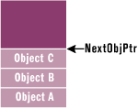
Figure 1 Managed Heap
At this point, NextObjPtr is incremented past the object so that it points to where the next object will be placed in the heap. Figure 1 shows a managed heap consisting of three objects: A, B, and C. The next object to be allocated will be placed where NextObjPtr points (immediately after object C).
Now let's look at how the C-runtime heap allocates memory. In a C-runtime heap, allocating memory for an object requires walking though a linked list of data structures. Once a large enough block is found, that block has to be split, and pointers in the linked list nodes must be modified to keep everything intact. For the managed heap, allocating an object simply means adding a value to a pointer—this is blazingly fast by comparison. In fact, allocating an object from the managed heap is nearly as fast as allocating memory from a thread's stack!
So far, it sounds like the managed heap is far superior to the C-runtime heap due to its speed and simplicity of implementation. Of course, the managed heap gains these advantages because it makes one really big assumption: address space and storage are infinite. This assumption is (without a doubt) ridiculous, and there must be a mechanism employed by the managed heap that allows the heap to make this assumption. This mechanism is called the garbage collector. Let's see how it works.
When an application calls the new operator to create an object, there may not be enough address space left in the region to allocate to the object. The heap detects this by adding the size of the new object to NextObjPtr. If NextObjPtr is beyond the end of the address space region, then the heap is full and a collection must be performed.
In reality, a collection occurs when generation 0 is completely full. Briefly, a generation is a mechanism implemented by the garbage collector in order to improve performance. The idea is that newly created objects are part of a young generation, and objects created early in the application's lifecycle are in an old generation. Separating objects into generations can allow the garbage collector to collect specific generations instead of collecting all objects in the managed heap. Generations will be discussed in more detail in Part 2 of this article.
The Garbage Collection Algorithm
The garbage collector checks to see if there are any objects in the heap that are no longer being used by the application. If such objects exist, then the memory used by these objects can be reclaimed. (If no more memory is available for the heap, then the new operator throws an OutOfMemoryException.) How does the garbage collector know if the application is using an object or not? As you might imagine, this isn't a simple question to answer.
Every application has a set of roots. Roots identify storage locations, which refer to objects on the managed heap or to objects that are set to null. For example, all the global and static object pointers in an application are considered part of the application's roots. In addition, any local variable/parameter object pointers on a thread's stack are considered part of the application's roots. Finally, any CPU registers containing pointers to objects in the managed heap are also considered part of the application's roots. The list of active roots is maintained by the just-in-time (JIT) compiler and common language runtime, and is made accessible to the garbage collector's algorithm.
When the garbage collector starts running, it makes the assumption that all objects in the heap are garbage. In other words, it assumes that none of the application's roots refer to any objects in the heap. Now, the garbage collector starts walking the roots and building a graph of all objects reachable from the roots. For example, the garbage collector may locate a global variable that points to an object in the heap.
Figure 2 shows a heap with several allocated objects where the application's roots refer directly to objects A, C, D, and F. All of these objects become part of the graph. When adding object D, the collector notices that this object refers to object H, and object H is also added to the graph. The collector continues to walk through all reachable objects recursively.
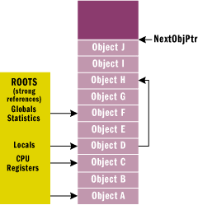
Figure 2 Allocated Objects in Heap
Once this part of the graph is complete, the garbage collector checks the next root and walks the objects again. As the garbage collector walks from object to object, if it attempts to add an object to the graph that it previously added, then the garbage collector can stop walking down that path. This serves two purposes. First, it helps performance significantly since it doesn't walk through a set of objects more than once. Second, it prevents infinite loops should you have any circular linked lists of objects.
Once all the roots have been checked, the garbage collector's graph contains the set of all objects that are somehow reachable from the application's roots; any objects that are not in the graph are not accessible by the application, and are therefore considered garbage. The garbage collector now walks through the heap linearly, looking for contiguous blocks of garbage objects (now considered free space). The garbage collector then shifts the non-garbage objects down in memory (using the standard memcpy function that you've known for years), removing all of the gaps in the heap. Of course, moving the objects in memory invalidates all pointers to the objects. So the garbage collector must modify the application's roots so that the pointers point to the objects' new locations. In addition, if any object contains a pointer to another object, the garbage collector is responsible for correcting these pointers as well. Figure 3 shows the managed heap after a collection.
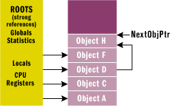
Figure 3 Managed Heap after Collection
After all the garbage has been identified, all the non-garbage has been compacted, and all the non-garbage pointers have been fixed-up, the NextObjPtr is positioned just after the last non-garbage object. At this point, the new operation is tried again and the resource requested by the application is successfully created.
As you can see, a GC generates a significant performance hit, and this is the major downside of using a managed heap. However, keep in mind that GCs only occur when the heap is full and, until then, the managed heap is significantly faster than a C-runtime heap. The runtime's garbage collector also offers some optimizations that greatly improve the performance of garbage collection. I'll discuss these optimizations in Part 2 of this article when I talk about generations.
There are a few important things to note at this point. You no longer have to implement any code that manages the lifetime of any resources that your application uses. And notice how the two bugs I discussed at the beginning of this article no longer exist. First, it is not possible to leak resources, since any resource not accessible from your application's roots can be collected at some point. Second, it is not possible to access a resource that is freed, since the resource won't be freed if it is reachable. If it's not reachable, then your application has no way to access it. The code in Figure 4 demonstrates how resources are allocated and managed.
If GC is so great, you might be wondering why it isn't in ANSI C++. The reason is that a garbage collector must be able to identify an application's roots and must also be able to find all object pointers. The problem with C++ is that it allows casting a pointer from one type to another, and there's no way to know what a pointer refers to. In the common language runtime, the managed heap always knows the actual type of an object, and the metadata information is used to determine which members of an object refer to other objects.
Finalization
The garbage collector offers an additional feature that you may want to take advantage of: finalization. Finalization allows a resource to gracefully clean up after itself when it is being collected. By using finalization, a resource representing a file or network connection is able to clean itself up properly when the garbage collector decides to free the resource's memory.
Here is an oversimplification of what happens: when the garbage collector detects that an object is garbage, the garbage collector calls the object's Finalize method (if it exists) and then the object's memory is reclaimed. For example, let's say you have the following type (in C#):
public class BaseObj {
public BaseObj() {
}

protected override void Finalize() {
// Perform resource cleanup code here...
// Example: Close file/Close network connection
Console.WriteLine("In Finalize.");
}
}
Now you can create an instance of this object by calling:
BaseObj bo = new BaseObj();
Some time in the future, the garbage collector will determine that this object is garbage. When that happens, the garbage collector will see that the type has a Finalize method and will call the method, causing "In Finalize" to appear in the console window and reclaiming the memory block used by this object.
Many developers who are used to programming in C++ draw an immediate correlation between a destructor and the Finalize method. However, let me warn you right now: object finalization and destructors have very different semantics and it is best to forget everything you know about destructors when thinking about finalization. Managed objects never have destructors—period.
When designing a type it is best to avoid using a Finalize method. There are several reasons for this:
- Finalizable objects get promoted to older generations, which increases memory pressure and prevents the object's memory from being collected when the garbage collector determines the object is garbage. In addition, all objects referred to directly or indirectly by this object get promoted as well. Generations and promotions will be discussed in Part 2 of this article.
- Finalizable objects take longer to allocate.
- Forcing the garbage collector to execute a Finalize method can significantly hurt performance. Remember, each object is finalized. So if I have an array of 10,000 objects, each object must have its Finalize method called.
- Finalizable objects may refer to other (non-finalizable) objects, prolonging their lifetime unnecessarily. In fact, you might want to consider breaking a type into two different types: a lightweight type with a Finalize method that doesn't refer to any other objects, and a separate type without a Finalize method that does refer to other objects.
- You have no control over when the Finalize method will execute. The object may hold on to resources until the next time the garbage collector runs.
- When an application terminates, some objects are still reachable and will not have their Finalize method called. This can happen if background threads are using the objects or if objects are created during application shutdown or AppDomain unloading. In addition, by default, Finalize methods are not called for unreachable objects when an application exits so that the application may terminate quickly. Of course, all operating system resources will be reclaimed, but any objects in the managed heap are not able to clean up gracefully. You can change this default behavior by calling the System.GC type's RequestFinalizeOnShutdown method. However, you should use this method with care since calling it means that your type is controlling a policy for the entire application.
- The runtime doesn't make any guarantees as to the order in which Finalize methods are called. For example, let's say there is an object that contains a pointer to an inner object. The garbage collector has detected that both objects are garbage. Furthermore, say that the inner object's Finalize method gets called first. Now, the outer object's Finalize method is allowed to access the inner object and call methods on it, but the inner object has been finalized and the results may be unpredictable. For this reason, it is strongly recommended that Finalize methods not access any inner, member objects.
If you determine that your type must implement a Finalize method, then make sure the code executes as quickly as possible. Avoid all actions that would block the Finalize method, including any thread synchronization operations. Also, if you let any exceptions escape the Finalize method, the system just assumes that the Finalize method returned and continues calling other objects' Finalize methods.
When the compiler generates code for a constructor, the compiler automatically inserts a call to the base type's constructor. Likewise, when a C++ compiler generates code for a destructor, the compiler automatically inserts a call to the base type's destructor. However, as I've said before, Finalize methods are different from destructors. The compiler has no special knowledge about a Finalize method, so the compiler does not automatically generate code to call a base type's Finalize method. If you want this behavior—and frequently you do—then you must explicitly call the base type's Finalize method from your type's Finalize method:
public class BaseObj {
public BaseObj() {
}

protected override void Finalize() {
Console.WriteLine("In Finalize.");
base.Finalize(); // Call base type's Finalize
}
}
Note that you'll usually call the base type's Finalize method as the last statement in the derived type's Finalize method. This keeps the object alive as long as possible. Since calling a base type Finalize method is common, C# has a syntax that simplifies your work. In C#, the following code
class MyObject {
~MyObject() {
•••
}
}
causes the compiler to generate this code:
class MyObject {
protected override void Finalize() {
•••
base.Finalize();
}
}
Note that this C# syntax looks identical to the C++ language's syntax for defining a destructor. But remember, C# doesn't support destructors. Don't let the identical syntax fool you.
Finalization Internals
On the surface, finalization seems pretty straightforward: you create an object and when the object is collected, the object's Finalize method is called. But there is more to finalization than this.
When an application creates a new object, the new operator allocates the memory from the heap. If the object's type contains a Finalize method, then a pointer to the object is placed on the finalization queue. The finalization queue is an internal data structure controlled by the garbage collector. Each entry in the queue points to an object that should have its Finalize method called before the object's memory can be reclaimed.
Figure 5 shows a heap containing several objects. Some of these objects are reachable from the application's roots, and some are not. When objects C, E, F, I, and J were created, the system detected that these objects had Finalize methods and pointers to these objects were added to the finalization queue.
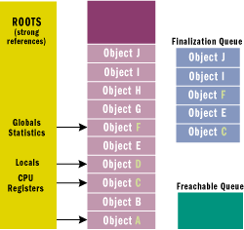
Figure 5 A Heap with Many Objects
When a GC occurs, objects B, E, G, H, I, and J are determined to be garbage. The garbage collector scans the finalization queue looking for pointers to these objects. When a pointer is found, the pointer is removed from the finalization queue and appended to the freachable queue (pronounced "F-reachable"). The freachable queue is another internal data structure controlled by the garbage collector. Each pointer in the freachable queue identifies an object that is ready to have its Finalize method called.
After the collection, the managed heap looks like Figure 6. Here, you see that the memory occupied by objects B, G, and H has been reclaimed because these objects did not have a Finalize method that needed to be called. However, the memory occupied by objects E, I, and J could not be reclaimed because their Finalize method has not been called yet.
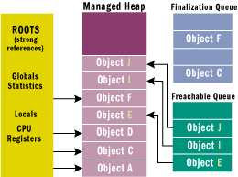
Figure 6 Managed Heap after Garbage Collection
There is a special runtime thread dedicated to calling Finalize methods. When the freachable queue is empty (which is usually the case), this thread sleeps. But when entries appear, this thread wakes, removes each entry from the queue, and calls each object's Finalize method. Because of this, you should not execute any code in a Finalize method that makes any assumption about the thread that's executing the code. For example, avoid accessing thread local storage in the Finalize method.
The interaction of the finalization queue and the freachable queue is quite fascinating. First, let me tell you how the freachable queue got its name. The f is obvious and stands for finalization; every entry in the freachable queue should have its Finalize method called. The "reachable" part of the name means that the objects are reachable. To put it another way, the freachable queue is considered to be a root just like global and static variables are roots. Therefore, if an object is on the freachable queue, then the object is reachable and is not garbage.
In short, when an object is not reachable, the garbage collector considers the object garbage. Then, when the garbage collector moves an object's entry from the finalization queue to the freachable queue, the object is no longer considered garbage and its memory is not reclaimed. At this point, the garbage collector has finished identifying garbage. Some of the objects identified as garbage have been reclassified as not garbage. The garbage collector compacts the reclaimable memory and the special runtime thread empties the freachable queue, executing each object's Finalize method.
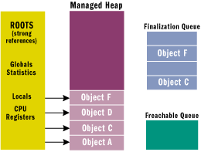
Figure 7 Managed Heap after Second Garbage Collection
The next time the garbage collector is invoked, it sees that the finalized objects are truly garbage, since the application's roots don't point to it and the freachable queue no longer points to it. Now the memory for the object is simply reclaimed. The important thing to understand here is that two GCs are required to reclaim memory used by objects that require finalization. In reality, more than two collections may be necessary since the objects could get promoted to an older generation. Figure 7 shows what the managed heap looks like after the second GC.
Resurrection
The whole concept of finalization is fascinating. However, there is more to it than what I've described so far. You'll notice in the previous section that when an application is no longer accessing a live object, the garbage collector considers the object to be dead. However, if the object requires finalization, the object is considered live again until it is actually finalized, and then it is permanently dead. In other words, an object requiring finalization dies, lives, and then dies again. This is a very interesting phenomenon called resurrection. Resurrection, as its name implies, allows an object to come back from the dead.
I've already described a form of resurrection. When the garbage collector places a reference to the object on the freachable queue, the object is reachable from a root and has come back to life. Eventually, the object's Finalize method is called, no roots point to the object, and the object is dead forever after. But what if an object's Finalize method executed code that placed a pointer to the object in a global or static variable?
public class BaseObj {

protected override void Finalize() {
Application.ObjHolder = this;
}
}

class Application {
static public Object ObjHolder; // Defaults to null
•••
}
In this case, when the object's Finalize method executes, a pointer to the object is placed in a root and the object is reachable from the application's code. This object is now resurrected and the garbage collector will not consider the object to be garbage. The application is free to use the object, but it is very important to note that the object has been finalized and that using the object may cause unpredictable results. Also note: if BaseObj contained members that pointed to other objects (either directly or indirectly), all objects would be resurrected, since they are all reachable from the application's roots. However, be aware that some of these other objects may also have been finalized.
In fact, when designing your own object types, objects of your type can get finalized and resurrected totally out of your control. Implement your code so that you handle this gracefully. For many types, this means keeping a Boolean flag indicating whether the object has been finalized or not. Then, if methods are called on your finalized object, you might consider throwing an exception. The exact technique to use depends on your type.
Now, if some other piece of code sets Application.ObjHolder to null, the object is unreachable. Eventually the garbage collector will consider the object to be garbage and will reclaim the object's storage. Note that the object's Finalize method will not be called because no pointer to the object exists on the finalization queue.
There are very few good uses of resurrection, and you really should avoid it if possible. However, when people do use resurrection, they usually want the object to clean itself up gracefully every time the object dies. To make this possible, the GC type offers a method called ReRegisterForFinalize, which takes a single parameter: the pointer to an object.
public class BaseObj {

protected override void Finalize() {
Application.ObjHolder = this;
GC.ReRegisterForFinalize(this);
}
}
When this object's Finalize method is called, it resurrects itself by making a root point to the object. The Finalize method then calls ReRegisterForFinalize, which appends the address of the specified object (this) to the end of the finalization queue. When the garbage collector detects that this object is unreachable again, it will queue the object's pointer on the freachable queue and the Finalize method will get called again. This specific example shows how to create an object that constantly resurrects itself and never dies, which is usually not desirable. It is far more common to conditionally set a root to reference the object inside the Finalize method.
Make sure that you call ReRegisterForFinalize no more than once per resurrection, or the object will have its Finalize method called multiple times. This happens because each call to ReRegisterForFinalize appends a new entry to the end of the finalization queue. When an object is determined to be garbage, all of these entries move from the finalization queue to the freachable queue, calling the object's Finalize method multiple times.
Forcing an Object to Clean Up
If you can, you should try to define objects that do not require any clean up. Unfortunately, for many objects, this is simply not possible. So for these objects, you must implement a Finalize method as part of the type's definition. However, it is also recommended that you add an additional method to the type that allows a user of the type to explicitly clean up the object when they want. By convention, this method should be called Close or Dispose.
In general, you use Close if the object can be reopened or reused after it has been closed. You also use Close if the object is generally considered to be closed, such as a file. On the other hand, you would use Dispose if the object should no longer be used at all after it has been disposed. For example, to delete a System.Drawing.Brush object, you call its Dispose method. Once disposed, the Brush object cannot be used, and calling methods to manipulate the object may cause exceptions to be thrown. If you need to work with another Brush, you must construct a new Brush object.
Now, let's look at what the Close/Dispose method is supposed to do. The System.IO.FileStream type allows the user to open a file for reading and writing. To improve performance, the type's implementation makes use of a memory buffer. Only when the buffer fills does the type flush the contents of the buffer to the file. Let's say that you create a new FileStream object and write just a few bytes of information to it. If these bytes don't fill the buffer, then the buffer is not written to disk. The FileStream type does implement a Finalize method, and when the FileStream object is collected the Finalize method flushes any remaining data from memory to disk and then closes the file.
But this approach may not be good enough for the user of the FileStream type. Let's say that the first FileStream object has not been collected yet, but the application wants to create a new FileStream object using the same disk file. In this scenario, the second FileStream object will fail to open the file if the first FileStream object had the file open for exclusive access. The user of the FileStream object must have some way to force the final memory flush to disk and to close the file.
If you examine the FileStream type's documentation, you'll see that it has a method called Close. When called, this method flushes the remaining data in memory to the disk and closes the file. Now the user of a FileStream object has control of the object's behavior.
But an interesting problem arises now: what should the FileStream's Finalize method do when the FileStream object is collected? Obviously, the answer is nothing. In fact, there is no reason for the FileStream's Finalize method to execute at all if the application has explicitly called the Close method. You know that Finalize methods are discouraged, and in this scenario you're going to have the system call a Finalize method that should do nothing. It seems like there ought to be a way to suppress the system's calling of the object's Finalize method. Fortunately, there is. The System.GC type contains a static method, SuppressFinalize, that takes a single parameter, the address of an object.
Figure 8 shows FileStream's type implementation. When you call SuppressFinalize, it turns on a bit flag associated with the object. When this flag is on, the runtime knows not to move this object's pointer to the freachable queue, preventing the object's Finalize method from being called.
Let's examine another related issue. It is very common to use a StreamWriter object with a FileStream object.
FileStream fs = new FileStream("C:\\SomeFile.txt",
FileMode.Open, FileAccess.Write, FileShare.Read);
StreamWriter sw = new StreamWriter(fs);
sw.Write ("Hi there");

// The call to Close below is what you should do
sw.Close();
// NOTE: StreamWriter.Close closes the FileStream. The FileStream
// should not be explicitly closed in this scenario
Notice that the StreamWriter's constructor takes a FileStream object as a parameter. Internally, the StreamWriter object saves the FileStream's pointer. Both of these objects have internal data buffers that should be flushed to the file when you're finished accessing the file. Calling the StreamWriter's Close method writes the final data to the FileStream and internally calls the FileStream's Close method, which writes the final data to the disk file and closes the file. Since StreamWriter's Close method closes the FileStream object associated with it, you should not call fs.Close yourself.
What do you think would happen if you removed the two calls to Close? Well, the garbage collector would correctly detect that the objects are garbage and the objects would get finalized. But, the garbage collector doesn't guarantee the order in which the Finalize methods are called. So if the FileStream gets finalized first, it closes the file. Then when the StreamWriter gets finalized, it would attempt to write data to the closed file, raising an exception. Of course, if the StreamWriter got finalized first, then the data would be safely written to the file.
How did Microsoft solve this problem? Making the garbage collector finalize objects in a specific order is impossible because objects could contain pointers to each other and there is no way for the garbage collector to correctly guess the order to finalize these objects. So, here is Microsoft's solution: the StreamWriter type doesn't implement a Finalize method at all. Of course, this means that forgetting to explicitly close the StreamWriter object guarantees data loss. Microsoft expects that developers will see this consistent loss of data and will fix the code by inserting an explicit call to Close.
As stated earlier, the SuppressFinalize method simply sets a bit flag indicating that the object's Finalize method should not be called. However, this flag is reset when the runtime determines that it's time to call a Finalize method. This means that calls to ReRegisterForFinalize cannot be balanced by calls to SuppressFinalize. The code in Figure 9 demonstrates exactly what I mean.
ReRegisterForFinalize and SuppressFinalize are implemented the way they are for performance reasons. As long as each call to SuppressFinalize has an intervening call to ReRegisterForFinalize, everything works. It is up to you to ensure that you do not call ReRegisterForFinalize or SuppressFinalize multiple times consecutively, or multiple calls to an object's Finalize method can occur.
Conclusion
The motivation for garbage-collected environments is to simplify memory management for the developer. The first part of this overview looked at some general GC concepts and internals. In Part 2, I will conclude this discussion. First, I will explore a feature called WeakReferences, which you can use to reduce the memory pressure placed on the managed heap by large objects. Then I'll examine a mechanism that allows you to artificially extend the lifetime of a managed object. Finally, I'll wrap up by discussing various aspects of the garbage collector's performance. I'll discuss generations, multithreaded collections, and the performance counters that the common language runtime exposes, which allow you to monitor the garbage collector's real-time behavior.

For background information see:
Garbage Collection: Algorithms for Automatic Dynamic Memory Management by Richard Jones and Rafael Lins (John Wiley & Son, 1996)
Programming Applications for Microsoft Windows by Jeffrey Richter (Microsoft Press, 1999)

Jeffrey Richter is the author of Programming Applications for Microsoft Windows (Microsoft Press, 1999) and is a co-founder of Wintellect (www.Wintellect.com), a software education, debugging, and consulting firm. He specializes in programming/design for .NET and Win32. Jeff is currently writing a Microsoft .NET Frameworks programming book and offers .NET technology seminars.

From the November 2000 issue of MSDN Magazine.
Get it at your local newsstand, or better yet, subscribe.

Module diagram

Start
New Card
Login
Transaction
Security Information
Verification
Stop

UML Diagrams

Use case diagram
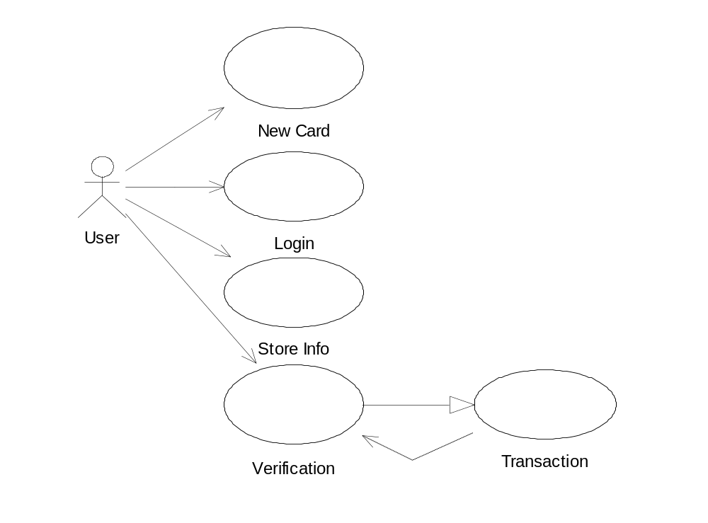

Class diagram

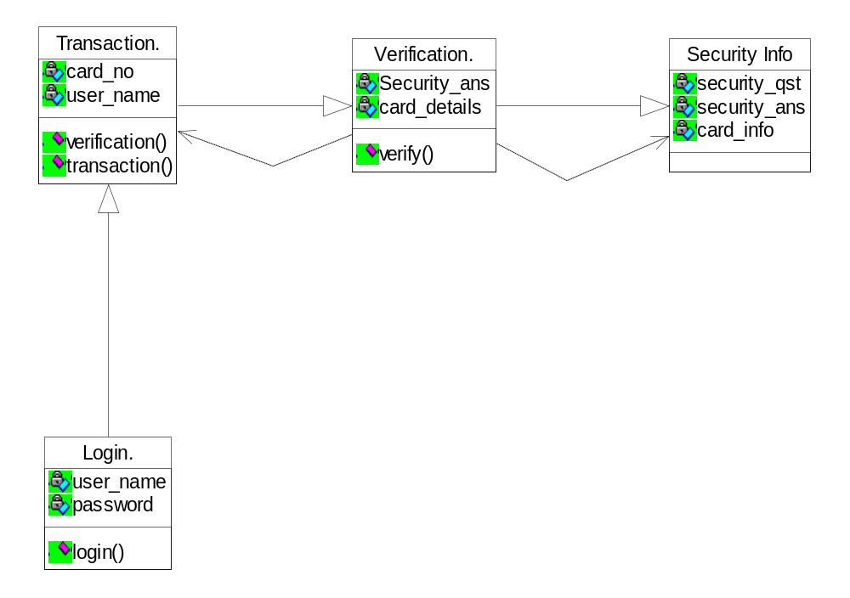

Object diagram
Login

Security Info
Transaction

Verification
Complete Transaction

State diagram

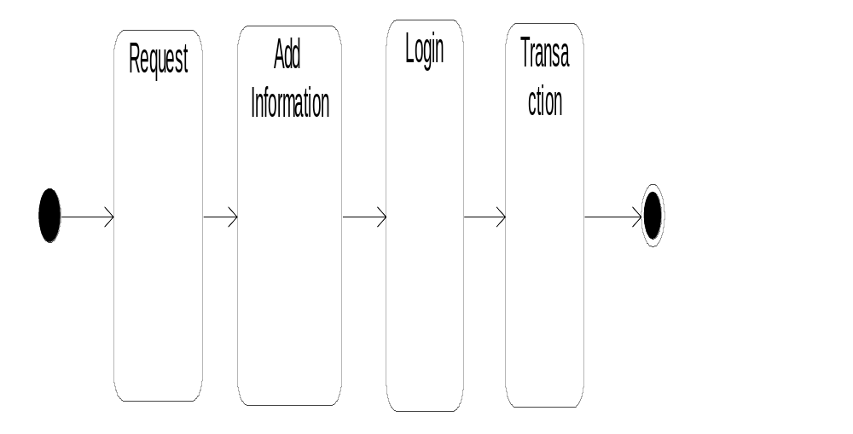

Activity diagram
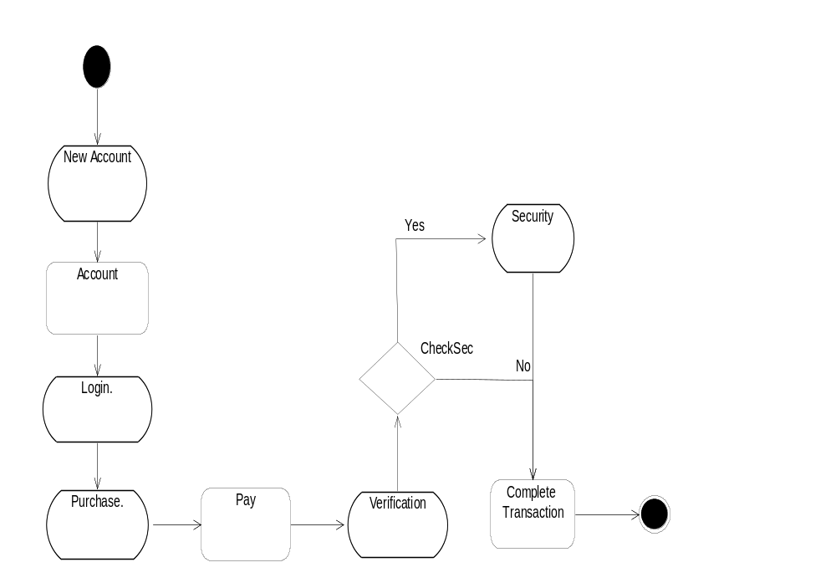

Sequence diagram

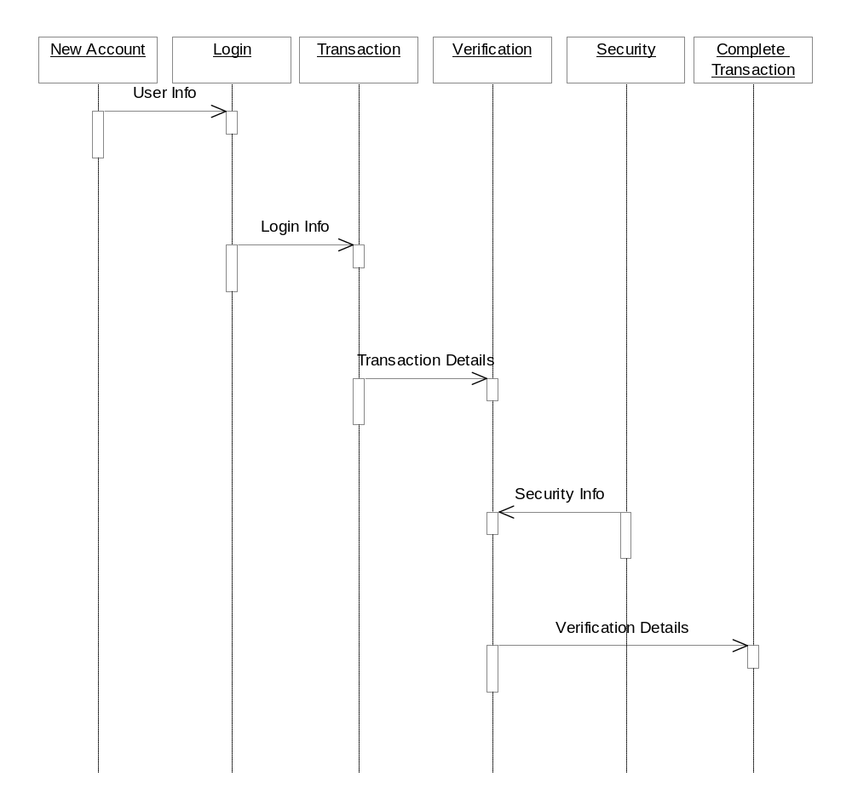

Collaboration Diagram

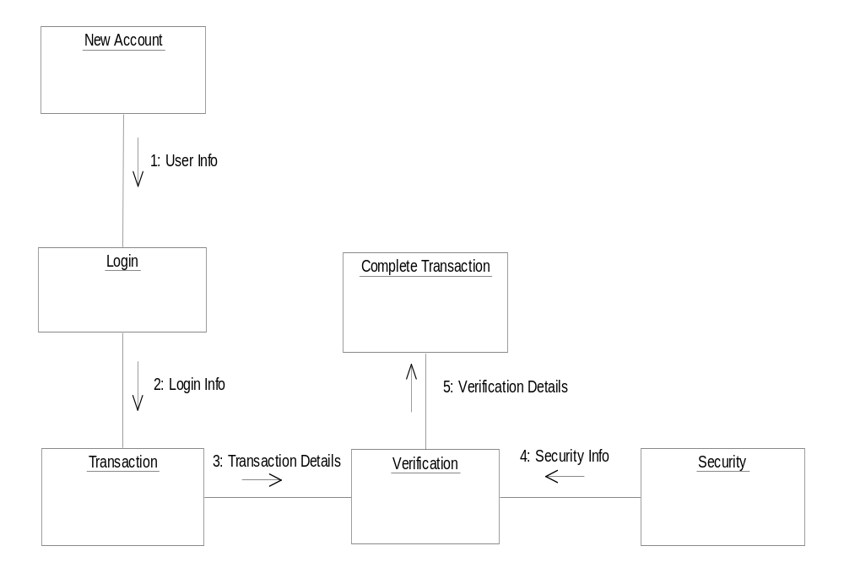

Component Diagram

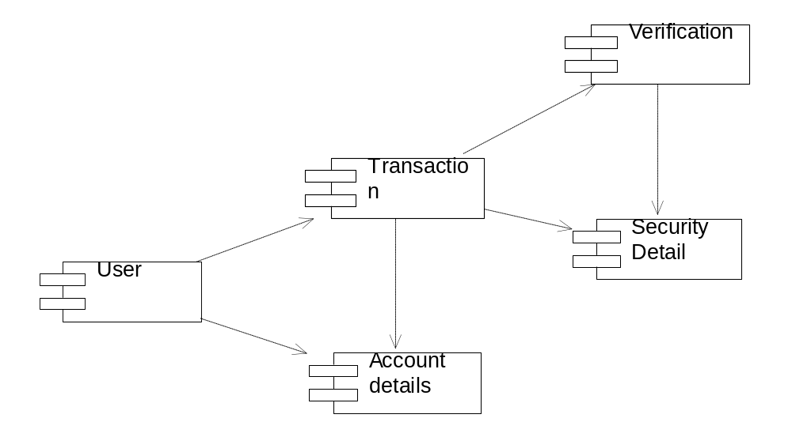

E-R diagram
User
Security
Account Details

Security details

Account History
HAS
Security
Transaction
HAS
Account Details
HAS
Verification
Card No.

Dataflow diagram

Account Details
Login
User
Transaction
Verification
Security
Complete Transaction

Project Flow Diagram

Start Transaction
Verification
Security
Account Area
User
User
User

System Architecture

User
Login Details
Login
Transaction
Account Details
Verification
Security
Complete n

Literature review
Ghosh and Reilly have proposed credit card fraud detection with a neural network. They have built a detection system, which is trained on a large sample of labeled credit card account transactions. These transactions contain example fraud cases due to lost cards, stolen cards, application fraud, counterfeit fraud, mail-order fraud, and nonreceived issue (NRI) fraud. Recently, Syeda et al. have used parallel granular neural networks (PGNNs) for improving the speed of data mining and knowledge discovery process in credit card fraud detection. A complete system has been implemented for this purpose. Stolfo et al. suggest a credit card fraud detection system (FDS) using metalearning techniques to learn models of fraudulent credit card transactions. Metalearning is a general strategy that provides a means for combining and integrating a number of separately built classifiers or models. A metaclassifier is thus trained on the correlation of the predictions of the base classifiers. The same group has also worked on a cost-based model for fraud and intrusion detection . They use Java agents for Metalearning (JAM), which is a distributed data mining system for credit card fraud detection. A number of important performance metrics like True Positive—False Positive (TP-FP) spread and accuracy have been defined by them. Aleskerov et al. present CARDWATCH, a database mining system used for credit card fraud detection. The system, based on a neural learning module, provides an interface to a variety of commercial databases. Kim and Kim have identified skewed distribution of data and mix of legitimate and fraudulent transactions as the two main reasons for the cmplexity of credit card fraud detection . Based on this observation, they use fraud density of real transaction data as a confidence value and generate the weighted fraud score to reduce the number of misdetections. Fan et al. suggest the application of distributed data mining in credit card fraud detection. Brause et al. have developed an approach that involves advanced data mining techniques and neural network algorithms to obtain high fraud coverage. Chiu and Tsai have proposed Web services and data mining techniques to establish a collaborative scheme for fraud detection in the banking industry. With this scheme, participating banks share knowledge about the fraud patterns in a heterogeneous and distributed environment. To establish a smooth channel of data exchange, Web services techniques such as XML, SOAP, and WSDL are used. Phua et al. have done an extensive survey of existing data-mining-based FDSs and published a comprehensive report. Prodromidis and Stolfo use an agent-based approach with distributed learning for detecting frauds in credit card transactions. It is based on artificial intelligence and combines inductive learning algorithms and metalearning methods for achieving higher accuracy. Phua .suggest the use of metaclassifier similar to infrauddetectionproblems.TheyconsidernaiveBayesian, C4.5, and Back Propagation neural networks as the base classifiers. A metaclassifier is used to determine which classifier should be considered based on skewness of data. Although they do not directly use credit card fraud detection as the target application, their approach is quite generic. Vatsa et al. have recently proposed a game-theoretic approach to credit card fraud detection. They model the interaction between anattackerandanFDSas a ltistagegamebetween two players, each trying to maximize his payoff. The problem with most of the abovementioned approaches is that they require labeled data for both genuine,
as well as fraudulent transactions, to train the classifiers. Getting real-world fraud data is one of the biggest problems associated with credit card fraud detection. Also, these approaches cannot detect new kinds of frauds for which labeled data is not available. In contrast, we present a Hidden Markov Model (HMM)-based credit card FDS, which does
not require fraud signatures and yet is able to detect frauds by considering a cardholder’s spending habit.Wemodel a credit card transaction processing sequence by the stochastic
process of an HMM. The details of items purchased in individual transactions are usually not known to an FDS running at the bank that issues credit cards to the cardholders. This can be represented as the underlying finite Markov chain, which is not observable. The transactions can only be observed through the other stochastic process that produces the sequence of the amount of money spent in each transaction. Hence, we feel that HMM is an ideal choice for addressing this problem. Another important advantage of the HMM-based approach is a drastic reduction in the number of False Positives (FPs)—transactions identified as malicious by an FDS although they are actually genuine. Since the number of genuine transactions is a few orders of magnitude higher than the number of malicious transactions, an FDS should be designed in such a way that the number of FPs is as low as possible.

Techniques and Algorithm Used

HMM Model

To map the credit card transaction processing operation in terms of an HMM, we start by first deciding the observation symbols in our model.Wequantize the purchase values x into M price ranges V1; V2; . . . VM, forming the observation symbols at the issuing bank. The actual price range for each symbol is configurable based on the spending habit of individual cardholders. These price ranges can be determined dynamically by applying a clustering algorithm on the values of each cardholder’s transactions, as shown in Section 5.2. We use Vk, k ¼ 1; 2; . . .M, to represent both the observation symbol, as well as the corresponding price range.
In this work, we consider only three price ranges, namely, low (l), medium (m), and high(h). Our set of observation symbols is, therefore, V ¼ fl; m; hg making M ¼ 3. For example, let l=(0, $100], m =($100,$500], and h=($500, credit card limit]. If a cardholder performs a transaction of $190, then the corresponding observation symbol is m.
A credit cardholder makes different kinds of purchases of different amounts over a period of time. One possibility is to consider the sequence of transaction amounts and look for deviations in them. However, the sequence of types of purchase is more stable compared to the sequence of transaction amounts. The reason is that, a cardholder makes purchases depending on his need for procuring different types of items over a period of time. This, in turn, generates a sequence of transaction amounts. Each individual transaction amount usually depends on the corresponding type of purchase. Hence, we consider the transition in the type of purchase as state transition in our model. The type of each purchase is linked to the line of business of the corresponding merchant. This information about the merchant’s line of business is not known to the issuing bank running the FDS. Thus, the type of purchase of the cardholder is hidden from the FDS. The set of all possible types of purchase and, equivalently, the set of all possible lines of business of merchants forms the set of hidden states of the HMM. It should be noted at this stage that the line of business of the merchant is known to the acquiring bank, since this information is furnished at the time of registration of a merchant. Also, some merchants may be dealing in various types of commodities (For example, Wal-Mart, K-Mart, or Target sells tens of thousands of different items). Such types of line of business are considered as Miscellaneous, and we do not attempt to determine the actual types of items purchased
in these transactions. Any assumption about availability of this information with the issuing bank and, hence, with the FDS, is not practical and, therefore, would not have been valid.

Advantages

Highly Security from unauthorized use of credit card

1. Avoids fraud usage of card through online transactions.

2. Detect if card used by others if card lost.

Applications

All the applications using credit cards.

Credit Card Fraud Detection Using
Hidden Markov Model
Screen Shot:

New Card:

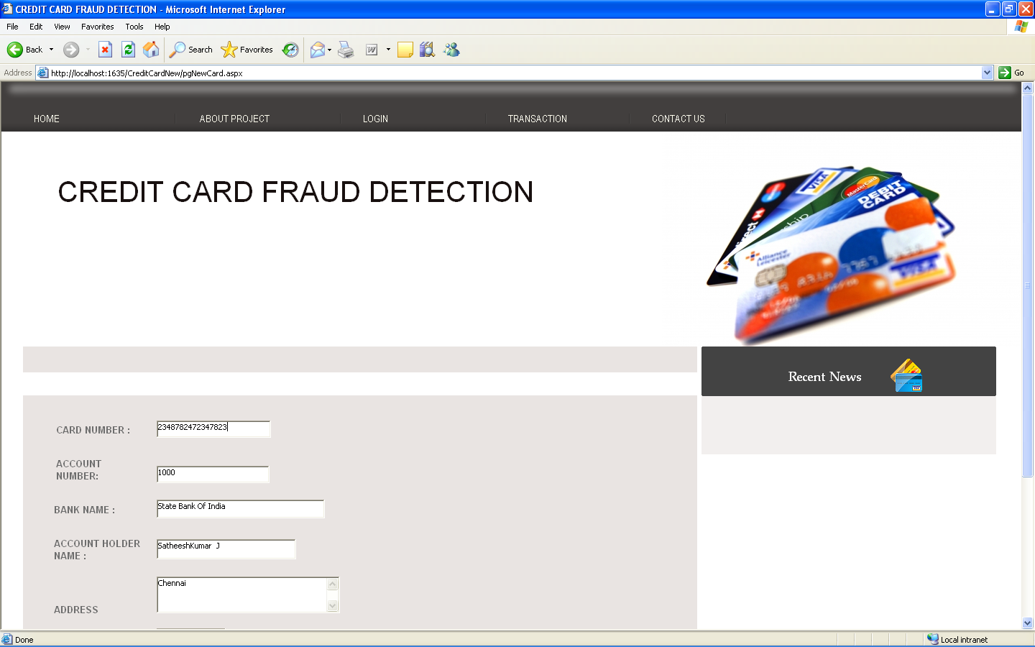

Login
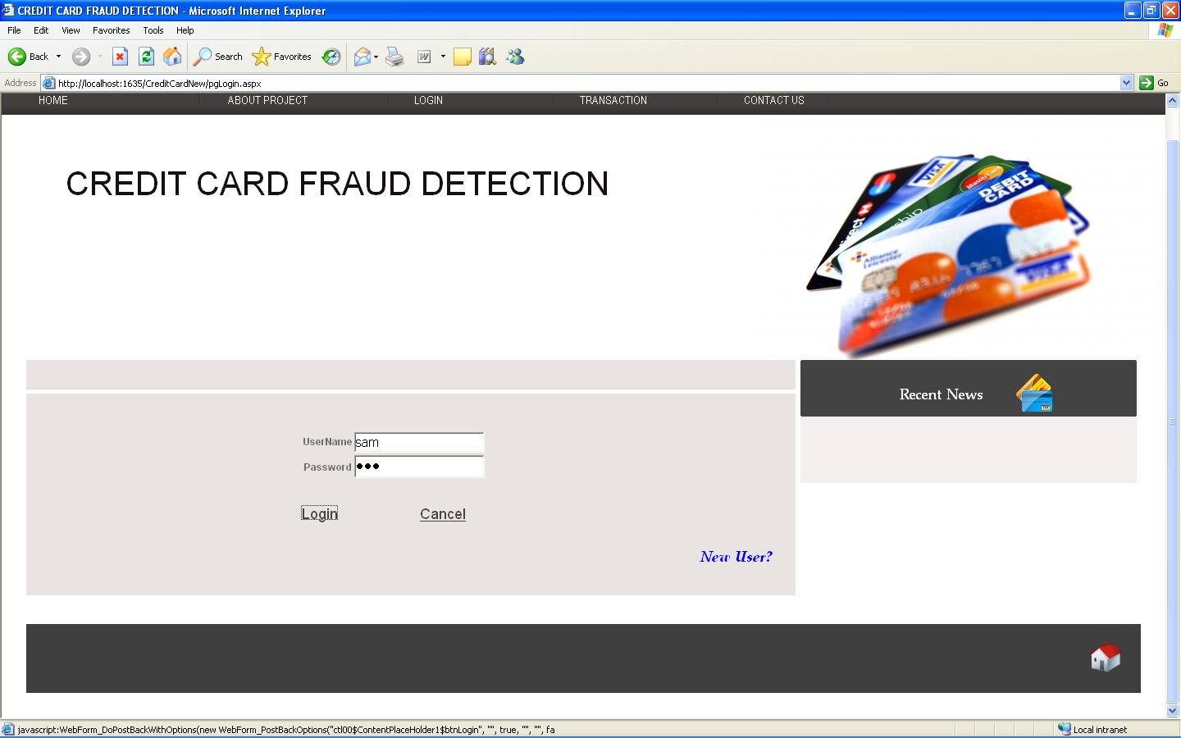

New Card

using System;
using System.Data;
using System.Configuration;
using System.Collections;
using System.Web;
using System.Web.Security;
using System.Web.UI;
using System.Web.UI.WebControls;
using System.Web.UI.WebControls.WebParts;
using System.Web.UI.HtmlControls;
using System.Data.SqlClient;

public partial class pgNewCard : System.Web.UI.Page
{
DataAccess data = new DataAccess();
protected void Page_Load(object sender, EventArgs e)
{

}
protected void btnSubmit_Click(object sender, EventArgs e)
{
data.DBOpen();

data.cmd = new SqlCommand("card_SP", data.cn);
data.cmd.CommandType = CommandType.StoredProcedure;

data.cmd.Parameters.Add(new SqlParameter("@cardNo", txtCardNo.Text));
data.cmd.Parameters.Add(new SqlParameter("@CreditLimit", Convert.ToInt32(txtAmt.Text)));
data.cmd.Parameters.Add(new SqlParameter("@holderName", txtACName.Text));
data.cmd.Parameters.Add(new SqlParameter("@HolderAddress", txtAddress.Text));
data.cmd.Parameters.Add(new SqlParameter("@BankName", txtBankName.Text));
data.cmd.Parameters.Add(new SqlParameter("@ACNO", txtACNO.Text));
try
{
data.cmd.ExecuteNonQuery();
}
catch (Exception ex)
{
Response.Write("<script>alert('Not a Vaild Card Number')</script>");
data.DBCmdClose();
}

data.DBCmdClose();

txtCardNo.Text = "";
txtAmt.Text = "";
txtACName.Text = "";
txtAddress.Text = "";
txtBankName.Text = "";
txtACNO.Text = "";

Response.Redirect("pgNewUser.aspx");
}
protected void txtCardNo_TextChanged(object sender, EventArgs e)
{
data.DBReaderOpen("select * from card where cardNo='" + txtCardNo.Text + "'");
if (data.dr.HasRows)
{
txtCardNo.Focus();
lblerror.Visible = true;
btnSubmit.Enabled = false;

}
else
{
txtACNO.Focus();
btnSubmit.Enabled = true;
}
}
}

Login

using System;
using System.Data;
using System.Configuration;
using System.Collections;
using System.Web;
using System.Web.Security;
using System.Web.UI;
using System.Web.UI.WebControls;
using System.Web.UI.WebControls.WebParts;
using System.Web.UI.HtmlControls;

public partial class pgLogin : System.Web.UI.Page
{
DataAccess data = new DataAccess();
protected void Page_Load(object sender, EventArgs e)
{
Session.Clear();
Session.Clear();
}
protected void btnLogin_Click(object sender, EventArgs e)
{
data.DBReaderOpen("Select * from Login where Uname='" + txtUName.Text + "' and pwd = '" + txtPass.Text + "'");
if (data.dr.HasRows)
{
data.dr.Read();
string roll = data.dr["Roll"].ToString();

if (roll.ToString() == "Admin")
{
Response.Redirect("pgadmin.aspx");
}
else
{
Session["uid"] = data.dr["uid"].ToString();
Response.Redirect("pgUsers.aspx");
}
}
else
{
Label3.Visible = true;
}

}
protected void btnCancel_Click(object sender, EventArgs e)
{
Response.Redirect("pgHome.aspx");
}
}
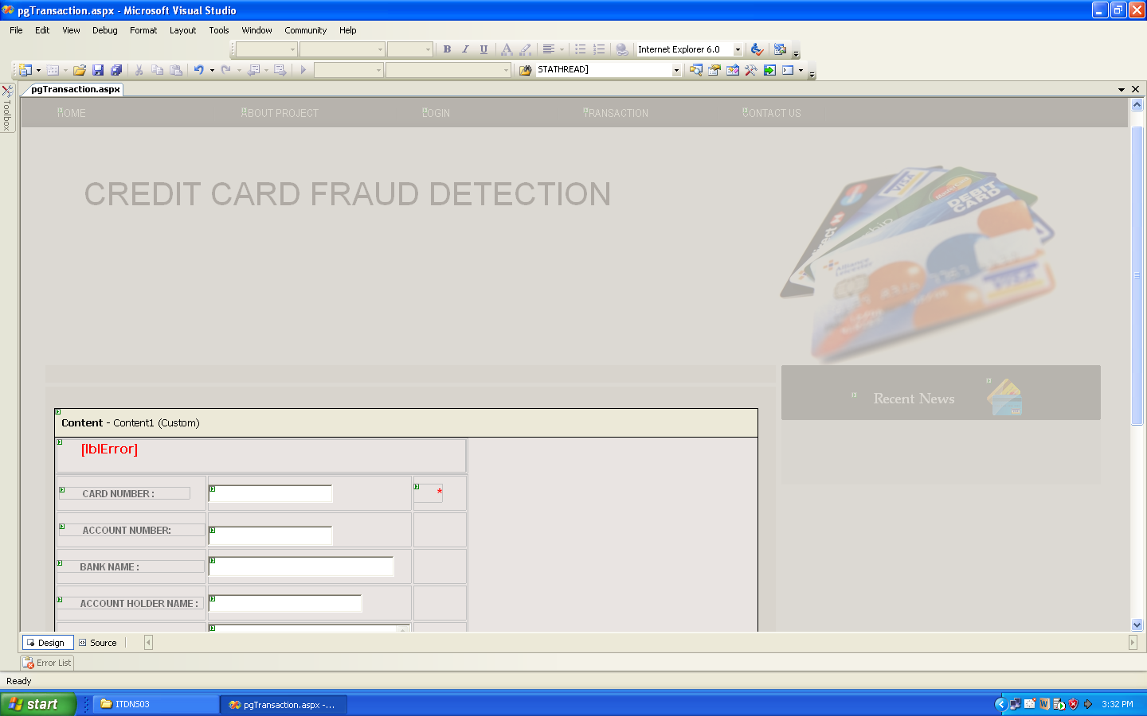

using System;
using System.Data;
using System.Configuration;
using System.Collections;
using System.Web;
using System.Web.Security;
using System.Web.UI;
using System.Web.UI.WebControls;
using System.Web.UI.WebControls.WebParts;
using System.Web.UI.HtmlControls;
using System.Data.SqlClient;

public partial class pgTransaction : System.Web.UI.Page
{
DataAccess data = new DataAccess();
int CreditLimit = 0;
int sumAmount = 0;
bool Amt = false;
bool Place = false;

protected void Page_Load(object sender, EventArgs e)
{
txtCardNo.Focus();
lblError.Visible = false;
txtAmt.Text = Session["amt"].ToString();
}

protected void txtCardNo_TextChanged(object sender, EventArgs e)
{
//TO check the user is blocked user or not
data.DBCmdOpen("Select * from fraud where cardNo='" + txtCardNo.Text + "'");
data.dr = data.cmd.ExecuteReader();
if (data.dr.HasRows)
{
lblError.Text= "Sorry Your Account Was Disabled";
lblError.Visible = true;
data.DBReaderClose();
}

else
{
data.DBReaderClose();
data.DBCmdOpen("Select * from card where cardNo='" + txtCardNo.Text + "'");
data.dr = data.cmd.ExecuteReader();
if (data.dr.HasRows)
{
data.dr.Read();
txtACNO.Text = data.dr["ACNO"].ToString();
txtACName.Text = data.dr["holderName"].ToString();
txtBankName.Text = data.dr["BankName"].ToString();
txtAddress.Text = data.dr["holderAddress"].ToString();
txtPalce.Focus();
btnSubmit.Enabled = true;
}
else
{
lblError.Text = "Sorry Invalid Card Number";
lblError.Visible = true;
txtCardNo.Focus();
btnSubmit.Enabled = false;
}
data.DBReaderClose();
}
}

protected void btnSubmit_Click(object sender, EventArgs e)
{
//To Sum The Total Amount made By the Card Holder
data.DBCmdOpen("select sum(amount) from account where cardNo='" + txtCardNo.Text + "'");
data.dr = data.cmd.ExecuteReader();
if (data.dr.HasRows)
{
data.dr.Read();
if (data.dr[0].ToString() == "")
{
sumAmount = 0;
}
else
{
sumAmount = Convert.ToInt32(data.dr[0].ToString());
}
}
data.DBReaderClose();

//To Find Whether the CreditLimit is Exceed
data.DBCmdOpen("select * from card where cardNo='" + txtCardNo.Text + "'");
data.dr = data.cmd.ExecuteReader();
if (data.dr.HasRows)
{
data.dr.Read();
CreditLimit = Convert.ToInt32(data.dr["CreditLimit"].ToString());
}
data.DBReaderClose();

// To Verify Genuine User Or Not
data.DBCmdOpen("select count(cardNo) from account where cardNo='" + txtCardNo.Text + "'");
data.dr = data.cmd.ExecuteReader();
if (data.dr.HasRows)
{
data.dr.Read();
if (data.dr[0].ToString() == "")
{
insertData();
}
else
{
int count = Convert.ToInt32(data.dr[0].ToString());
data.DBReaderClose();
if (count <= 3)
{
insertData();
}
else
{
int tranAmt = Convert.ToInt32(txtAmt.Text);
string trnPlace = txtPalce.Text;

//To Get all the transaction palce and amount to verify the current transction

data.DBReaderOpen("Select * from account where cardNo='" + txtCardNo.Text + "'");

if (data.dr.HasRows)
{
while (data.dr.Read())
{
if (data.dr["PlaceofTransaction"].ToString() == txtPalce.Text)
{
Place = true;
break;
}
}

}
data.DBReaderClose();

data.DBReaderOpen("select min(amount) as Min ,max(amount) as max from account where cardNo='" + txtCardNo.Text + "'");

if (data.dr.HasRows)
{
data.dr.Read();
{
int min = Convert.ToInt32(data.dr["Min"].ToString());
int max = Convert.ToInt32(data.dr["Max"].ToString());

if (min <= Convert.ToInt32(txtAmt.Text) && max >= Convert.ToInt32(txtAmt.Text))
{
Amt = true;
}
}

}

if (Amt && Place)
{
insertData();
}
else if (Amt)
{
insertData();
}
else
{
data.DBReaderOpen("Select uid from userInfo where cardNo='" + txtCardNo.Text + "'");
if (data.dr.HasRows)
{
data.dr.Read();
{
Session["TranUid"] = data.dr["uid"].ToString();
Session["CardNo"] = txtCardNo.Text;
Session["AccountNo"] = txtACNO.Text;
Session["BankName"] = txtBankName.Text;
Session["HolderName"] = txtACName.Text;
Session["Address"] = txtAddress.Text;
Session["Place"] = txtPalce.Text;
Session["PlaceId"] = txtPlaceId.Text;
Session["Amt"] = txtAmt.Text;
Session["SumAmount"] = sumAmount;
Session["creditLimit"] = CreditLimit;
Response.Redirect("pgVerification.aspx");
}
}
}

}

}

}
}
void insertData()
{

if (Convert.ToInt32(txtAmt.Text) + sumAmount <= CreditLimit)
{
data.DBOpen();

data.cmd = new SqlCommand("Account_SP", data.cn);
data.cmd.CommandType = CommandType.StoredProcedure;

data.cmd.Parameters.Add(new SqlParameter("@cardNo", txtCardNo.Text));
data.cmd.Parameters.Add(new SqlParameter("@holderName", txtACName.Text));
data.cmd.Parameters.Add(new SqlParameter("@HolderAddress", txtAddress.Text));
data.cmd.Parameters.Add(new SqlParameter("@ACNO", txtACNO.Text));
data.cmd.Parameters.Add(new SqlParameter("@BankName", txtBankName.Text));
data.cmd.Parameters.Add(new SqlParameter("@PlaceofTransaction", txtPalce.Text));
data.cmd.Parameters.Add(new SqlParameter("@PlaceId", Convert.ToInt32(txtPlaceId.Text)));
data.cmd.Parameters.Add(new SqlParameter("@Amount", Convert.ToInt32(txtAmt.Text)));
data.cmd.Parameters.Add(new SqlParameter("@DateTime", DateTime.Now));

data.cmd.ExecuteNonQuery();
data.DBCmdClose();
}
else
{
lblError.Text = "Sorry You are Exceed the Credit Limit";
lblError.Visible = true;
}

txtPalce.Text = "";
txtPlaceId.Text = "";
txtCardNo.Text = "";
txtBankName.Text = "";
txtAmt.Text = "";
txtAddress.Text = "";
txtACNO.Text = "";
txtACName.Text = "";
}
}
SYSTEM TESTING

CHAPTER 6

SYSTEM TESTING
In this chapter the various testing techniques that have been applied in the project during its development is discussed.

6.1 INTRODUCTION
When a system is to be developed, it is hoped that it performs properly. In practice, some errors always occur. The main purpose of testing a system is to find the errors and correct them. A successful test is one which finds an error. The main objectives of system testing are:

- To ensure that during operation the system will perform as per specification
- To make sure that the system meets user’s requirements during .operation.
- To verify that the controls incorporated in the system function as intended.
- To make sure when correct inputs are fed to the system, the outputs are correct.
- To make sure that during operation, incorrect input, processing and outputs will be deleted.

System testing is actually a series of different tests whose main purpose is to fully exercise the computer-based system. Although each testing has different purpose, all work to verify that system elements have been properly integrated and perform allocated function.

6.2 PERFORMANCE TESTING
Performance test is designed to test the run- time performance of the software within the context of an integrated system. Tests are based on coverage of code statements, branches, paths, conditions.

6.3 UNIT TESTING
Testing of individual software components or modules. Typically done by the programmer and not by testers, as it requires detailed knowledge of the internal program design and code.

6.4 INTEGRATION TESTING
Testing of integrated modules to verify combined functionality after integration. Modules are typically code modules, individual applications, client and server applications on a network, etc. This type of testing is especially relevant to client/server and distributed systems.

REFERENCES

[1] G. Li, “Efficient Network Authentication Protocols: Lower Bounds and
Optimal Implementations,” Distributed Computing, vol. 9, no. 3, pp. 131-145, 1995.

[2] A. Kehne, J. Schonwalder, and H. Langendorfer, “A Nonce-Based Protocol for Multiple Authentications,” ACM Operating Systems Rev., vol. 26, no. 4, pp. 84-89, 1992.

[3] M. Bellare and P. Rogaway, “Provably Secure Session Key Distribution: The Three Party Case,” Proc. 27th ACM Symp. Theory of Computing, pp. 57-66, 1995.

[4] J. Nam, S. Cho, S. Kim, and D. Won, “Simple and Efficient Group Key Agreement Based on Factoring,” Proc. Int’l Conf. Computational Science and Its Applications (ICCSA ’04), pp. 645-654, 2004.

[5] H.A. Wen, T.F. Lee, and T. Hwang, “A Provably Secure Three- Party Password-Based Authenticated Key Exchange Protocol Using Weil Pairing,” IEE Proc. Comm., vol. 152, no. 2, pp. 138-143, 2005

